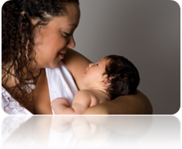
Personal Recommendation for _____________________
Name of Breastfeeding Counselor Applicant
Breastfeeding USA Breastfeeding Counselor Applicant

Thank you for submitting a recommendation for a volunteer Breastfeeding Counselor (BC) for Breastfeeding USA. Your response will be kept confidential. Please email the completed form directly to: Applicantsupport@BreastfeedingUSA.org noting the name of the applicant you are recommending in the subject line. Or send to: PO Box 44, Phelps, NY 14532.
BCs will offer evidence-based breastfeeding information and support to women in their communities through a variety of venues, including in person meetings. BCs may also participate in or moderate our online forums as representative of Breastfeeding USA and help mothers by e-mail or phone. To learn more about what we look for in a BC candidate, please see our prerequisites here: https://breastfeedingusa.org/content/personal-experience-requirements

Your Name:_______________________________________________________________
Address:_____________________________________________________ ____________
Phone: __________________________E-mail:__________________________________

- What is your personal experience with breastfeeding mothers (if applicable):

- How long have you known the applicant and in what capacity?

- Having read the description of a Breastfeeding Counselor's responsibilities, what personal skills or traits makes this applicant a good candidate?

- Please describe any reservations you may have about recommending this person to be a Breastfeeding Counselor Candidate.

